Name_______________________________________________________________________Summer 2014_
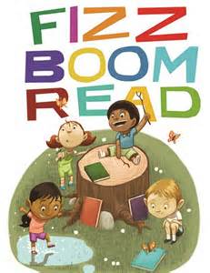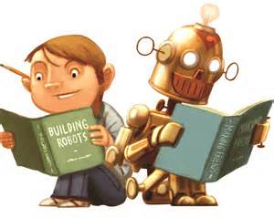
Please list all of the books you have read this summer. Remember, you are required to read 2 chapter books and a nonfiction book. Any additional reading should be listed and will be given extra credit.
Title of Story | Author | Genre (fiction/nonfiction) | Chapter book or picture book?

